AGENDA

Board of Commissioners Meeting
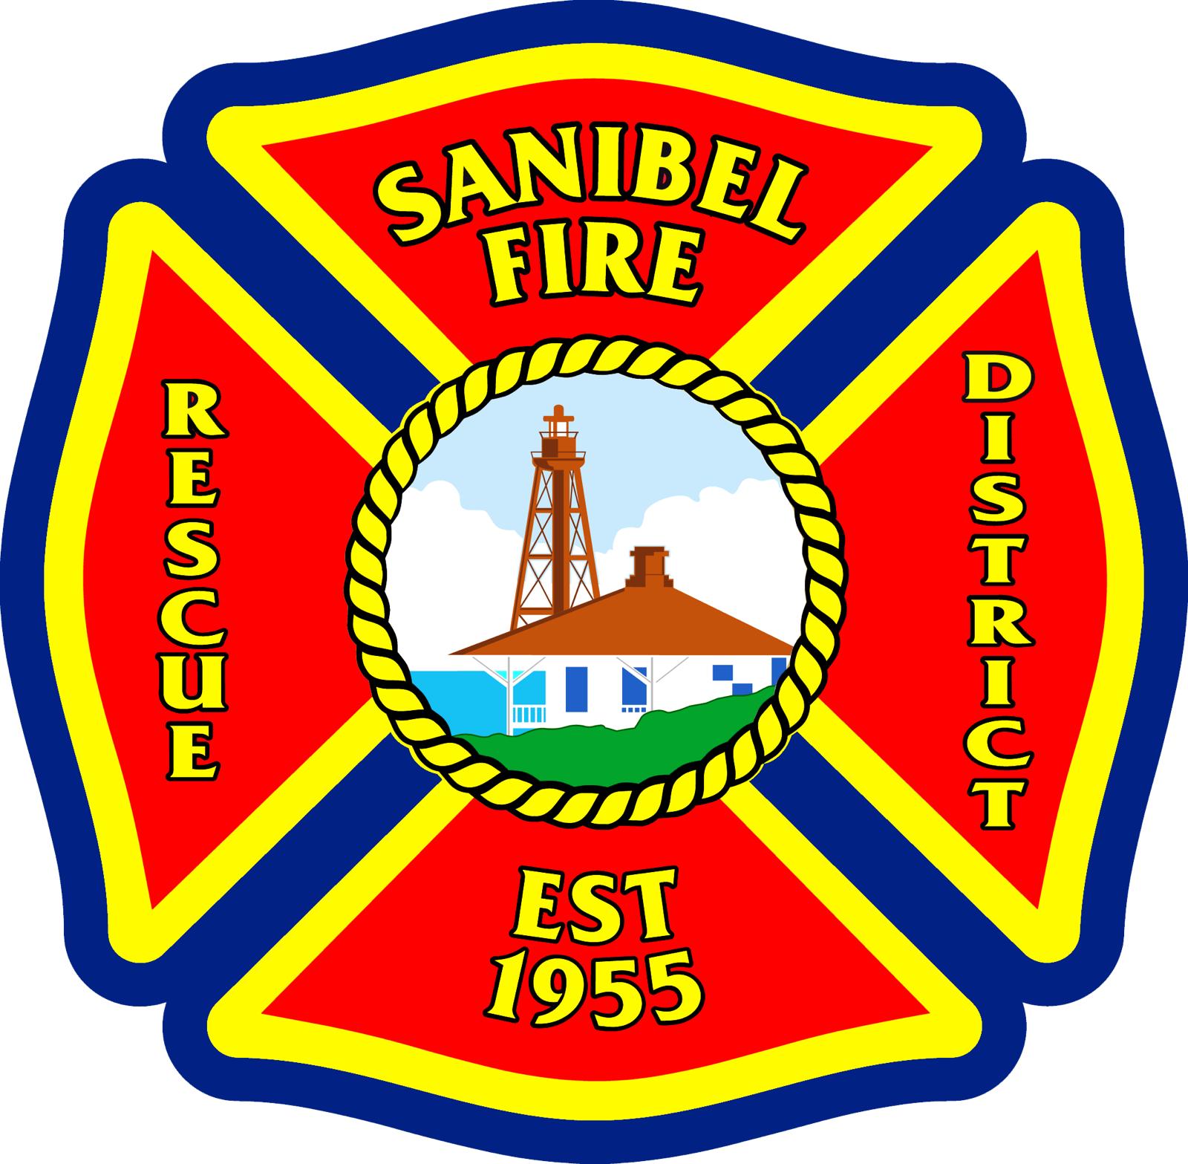
Sanibel Fire & Rescue District
2351 Palm Ridge Road Sanibel Florida 33957
Wednesday, September 20th, 2023
3:30 PM

Meeting Called to Order
Roll Call
Pledge of Allegiance
Minutes from the July meeting.

Division Chief of Prevention Report:
- Fire Inspections Report
- Fire Plans Review Report
Deputy Chief DiMaria Report:
- Personnel Training
- Public Education
- Review Call Volumes
- Community Involvement
Chief’s Report
- Financial Update
District Financial Report -
We will end the fiscal year barely under budget even with all of our hardships throughout this year. Many costly unexpected expenses were a direct result of the storm. Another big expenditure this year was the increased maintenance cost on front line apparatus.
We are working on many funding sources to assist the district as we recover from Ian’s financial aftermath. Information will be released when obligations and awards are received by the district.
I will be attending a delegation meeting at FSW in October. The district will be submitting appropriations to the house and senate to obtain additional funding to rebuild station 172. I am working with Chris Lyon of LLW to complete the bills.
Tax Rebate Refund From State of Florida Status
We have submitted our request for full reimbursement of the $671 thousand dollars that the district was responsible for refunding property taxes per legislative action. The dept of revenue will review the application and get back to TA’s mid to late October.
FEMA Status
Weekly Meeting – FEMA continues to request many documentations. Captain Mike Martin and I have been working diligently through this process. Over the last month, we have been working on obtaining confirmation of our flood elevation requirements for the new build along with other FEMA mandated building requirements. We are working very hard to ensure that any federal public assistance funding is not compromised by simply not following FEMA guidelines. This also includes with the way the district is proceeding with procurements.
Design and Development progress on station 172
60% Design and Development package has been delivered to the district. We are currently awaiting our 2nd / 60% station cost estimation numbers. The land survey were completed and sent over today. Engineering has been waiting for this survey to finish their portion of the work. The district will need to request a variance from the planning committee due to building heights. We will then enter the next steps of the process with the city which will include permitting.
Insurance – Work Comp / Property, Auto, and Liability
Work Comp has been renewed with longtime carrier PGIT, as the lowest bidder.
Property, Auto, and Liability has also been renewed with VFIS, also as the lowest bidder. @ $88 thousand.
Cost and increases likely to continue for the next 2-3 years. Instead of an immediate increase VFIS is doing gradual annual increases. It would not surprise me to see increases in the area of $200k.

- District Update -
Staffing Updates – Promotions, New Hires, Responsibility changes.

Effective Monday – The district will have 2 new Captain – Mike Martin and Robert Wilkins. We want to congratulate both of them on a job well done. These are 2 of our employees that have shown pride and high level of dedication for our district.

Captain Chris Jackson will be moving into an administrative role as Assistant Chief. Chief Jackson will be responsible for many different duties – Construction Manager for station 172, Logistics, Grants and federal funding, assist Fire Marshal Williams with the prevention department, and various other duties as dictated by DC DiMaria and Myself.
Chief Jackson is another outstanding employee that has spent hundreds of hours on and off duty continuing to work on projects to make our district a better place for not only our constituents but also our staff.
The district has 1 new hire, Ronnie Petito, that started his career with our district on August 28th. We have an additional hire starting next Monday, Dayan Conception. Both probationary FF’s are ecstatic to be working for our district.

Hurricane Idalia – Response / Update

Extra Staffing overnight / DC and myself stayed the night, we had a busy night, we experienced minor flooding in regularly flood prone areas.

This was a great trial run for FD, PD, city admin staff and public works to coordinate storm efforts.

Communication was excellent across all agencies.

Passed Safety Inspection – Compliant with Florida Administrative Code 69A-62 - Firefighter Employment Standards

Performance Review – Initial Meeting
Talk about the extension given by legislators.
Community Involvement -
End of Year / Awards Banquet
- Equipment / Maintenance Update
Costly Maintenance on apparatus during FY23
Annual Ladder Testing was Completed with no Issues.
F250 / Beach Rescue Vehicle Update
Upcoming Project – Generator for trailer.

Business Agenda Items
- Appoint Financial Auditor Selection Committee for RFP (Motion)
- Establish Factors to Evaluate Financial Auditors for RFP (Motion)
- Direct Fire Chief to Issue Financial Auditor RFP Consistent with Established Evaluation Factors (Motion)
Commissioner / New Business Items
Union Items
Public Input
Adjournment

